Abstraction hides complexity by exposing only essential features. it's a process to translate a complex things in a easy things to be understand for users and developers. focus, on essentials and hide details.

This way have a lot advantages like facilitates coding and improves maintainability . It's helps to go faster to translate needs or desire of users or clients in It concepts.

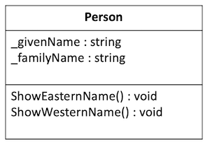for instance of abstraction: think about a person  look like :

Example from my own code:

public class Entry

{

  //attributes

  public string _date;

  public string _promptText;

  public string _entryText;

  PromptGenerator promptGenerator = new PromptGenerator();// **Abstraction**

  //methods

  public void Display()

  {

// **Abstraction : we use GetRandomPrompt() without know his intern functionment**

    _promptText = promptGenerator.GetRandomPrompt();

    Console.WriteLine(_promptText);

    _entryText = Console.ReadLine();

    DateTime dateWithoutHour = DateTime.Now.Date;

    _date = dateWithoutHour.ToString("dd/MM/yyyy");

  }

}